# Appendix A: Sugarloaf Creek Basin Site Information

*Table A1. All fires from FRAP (2017) perimeter database the burned within SCB. Fires included in the analysis burned 57% of SCB.*

|  |  |  |  |  |  |
| --- | --- | --- | --- | --- | --- |
| Year | Name | Report date | Total area (ha) | Area of watershed burned (ha) | Included in analyses? |
| 1952 | Sugarloaf | 19-Jun | 15 | 15 |  |
| 1964 | Williams | 2-Oct | 5 | 5 |  |
| 1971 | Ball Dome | 13-Aug | 99 | 99 |  |
| 1972 | Sugar Valley | 15-Sep | 16 | 5 |  |
| 1973 | So. Sentinel | 28-Aug | 1084 | 1038 | Y |
| 1974 | Comanche | 22-Jul | 1219 | 1219 | Y |
| 1976 | In Between | 29-Jul | 13 | 13 | Y |
| 1977 | Sugarloaf | 20-Jul | 264 | 264 | Y |
| 1977 | Ferguson | 26-Jun | 4219 | 1594 | Y |
| 1980 | Roaring | 1-Aug | 170 | 72 | Y |
| 1985 | Sugarloaf | 28-Jul | 1153 | 1152 | Y |
| 1988 | Sugarbaby | 20-Jun | 3 | 3 | Y |
| 1992 | Ellis Meadow | 2-Jun | 23 | 23 | Y |
| 1997 | Sugarloaf | 15-Aug | 114 | 114 | Y |
| 1999 | Williams | 18-Sep | 232 | 232 | Y |
| 2003 | Williams | 28-Jul | 1429 | 1427 | Y |
| 2004 | Ferguson | 7-Jul | 1 | 1 |  |
| 2006 | Pond | 13-Aug | 5 | 0 |  |

*Table A2. Specific discharge (total streamflow volume divided by watershed area) from the Merced Watershed (which contains ICB) and South Fork Kings River Watershed (which contains SCB) illustrate drier conditions in the region including SCB.*

|  |  |  |  |  |  |  |
| --- | --- | --- | --- | --- | --- | --- |
| **Large Watershed** | **Sub-Watershed Measurement Point** | **Gage # or Data Source** | **Lat/Lon** | **Sub-watershed Area** | **Years** | **Mean Annual Specific Discharge (Flow/Area)** |
| South Fork Kings | SF Kings River Near Cedar Grove, CA | USGS  11212500 | 36o48’25” N 118o44’55” W | 1056 km2 | 1950-1957 | 0.55 m/yr |
| South Fork Kings | Kings River near Hume, CA | USGS  11213000 | 36o50’50” N  118o53’50” W | 2160 km2 | 1921-1958 | 0.48 m/yr |
| Merced | Illilouette Creek at Ill. Falls Bridge | irma.nps.gov/AQWebPortal | 37°42′43″ N 119°33′35″ W | 150 km2 | 2011-2017 | 0.8 m/yr |
| Merced | Illilouette Creek at base of Illilouette Falls | Modeled (Boisrame et al. 2019, in review) | 37°43'32"N 119°33'27"W | 150 km2 | 1972-2017 | 0.9 m/year |
| Merced | Merced River at Happy Isles Bridge nr Yosemite CA | USGS 11264500 | 37°43’53″ N 119°33’33″ W | 469 km2 | 1921-1958 | 0.66 m/yr |
| Merced | Merced River at Pohono Bridge nr Yosemite CA | USGS 11266500 |  | 831 km2 | 1921-1958 | 0.65 m/yr |

# Appendix B: Sugarloaf Creek Basin and Illilouette Creek Basin weather station sites

We installed three temporary weather stations in Sugarloaf Creek Basin (SCB) in September 2016, with one weather station each in dense meadow, shrub, and mature mixed conifer vegetation types. The dense meadow weather station site is characterized by high soil moisture content, grass cover, and some conifer regeneration, but no overstory above the weather station. This weather station is situated in a local patch that burned at high severity in 2003 (this severity characterization is based on a visual assessment of fire-killed trees, which was corroborated by aerial photographs showing complete removal of forest cover in these local patches). The shrub regeneration site is characterized by drier soils, whitethorn ceanothus (*Ceanothus cordulatus*) growth with some grasses, and some conifer regeneration, but no overstory above the station. This site was also within a local patch of high severity from the 2003 fire (based on the same assessment criteria as above). Unlike the shrub weather station site at ICB (Boisramé et al. 2017a), the shrub weather station site at SCB does not have continuous shrub cover, as sites with continuous shrub cover were generally rare in SCB, and absent from the area where the co-located weather stations could be installed. The mixed conifer site is characterized by dry soils, overstory above the station, little herbaceous vegetation, and mature mixed conifers. This site burned at low severity in 2003 (based on visual observations of mature trees having survived the 2003 fire and confirmed by remotely-sensed burn severity data).

We compared the soil moisture observations at the weather stations to measurements made with the hand-held soil moisture meter. To do this, we used the hand-held meter to measure soil moisture integrated across the top 12 cm of soil, taking measurements in a grid around each weather station site, and compared these measurements to continuous soil moisture measurements collected at 12 cm depth at each weather station using buried TDR probes. On May 23rd, 2017, the spatially-distributed soil moisture means for the wetland, shrub, and forest stations were 48%±13%, 7.5%±1.8%, and 8.7%±2.3% respectively. For the same collection date, the wetland, shrub, and forest weather stations’ 12 cm soil moisture sensors measured 49%, 10%, and 11% respectively. On August 5th (wetland and forest) and 9th (shrub), 2017, spatially-distributed soil moisture data for wetland, shrub, and forest stations were 41%±14%, 1.0%±0.6%, and 1.3%±1.2% respectively, while the weather stations’ 12 cm soil moisture sensors measured 49%, 2.2%, and 2.9% respectively. Our measurements of spatially-distributed soil moisture were slightly but consistently lower than soil moisture data measured by the weather stations at equivalent depths. This is unsurprising because manually collected soil moisture measures average soil water content vertically from the surface to the depth of 12 cm, while the buried moisture probes measure average soil water content horizontally at the depth of 12 cm.

Soil samples were collected during installation of the soil moisture probes at each weather station, and analyzed for organic matter content as well as soil texture. Soil types were loamy sand or sand at all sites and depths, with shallow wetland soils in both ICB and SCB showing higher organic matter and silt content (Table B1).

*Table B1: Soil texture and organic matter (OM) percent composition for soil samples collected at the weather stations at different depths. For comparison, we also include an additional dense meadow site near the wetland weather station in ICB. “NA” indicates where there was insufficient sample for analysis.*

|  |  |  |  |  |  |  |
| --- | --- | --- | --- | --- | --- | --- |
| **Watershed** | **Site** | **Depth (cm)** | **Sand %** | **Silt %** | **Clay %** | **OM %** |
| **ICB** | Wetland | 0-10 | 71.3 | 10.4 | 6.1 | 13.0 |
| 50-60 | 84.4 | 7.9 | 5.9 | 1.8 |
| 90-100 | 88.8 | 4.9 | 4.9 | 1.3 |
| Near Wetland | 0-10 | 86.8 | 3.9 | 5.8 | 3.5 |
| 20-30 | 85.5 | 5.8 | 5.8 | 2.8 |
| Shrub | 0-10 | 88.0 | 5.9 | 3.9 | 2.2 |
| 50-60 | 89.8 | 3.9 | 4.9 | 1.3 |
| 90-100 | NA | NA | NA | 1.3 |
| Forest | 0-10 | 87.6 | 5.9 | 4.9 | 1.6 |
| 50-60 | 90.8 | 3.0 | 4.9 | 1.3 |
| 90-100 | 89.9 | 4.0 | 4.9 | 1.2 |
| **SCB** | Wetland | 0-12 | 72.9 | 13.1 | 7.5 | 6.5 |
| 50-60 | 80.2 | 8.8 | 8.8 | 2.3 |
| 90-100 | 79.4 | 9.8 | 8.8 | 2.0 |
| Shrub | 0-12 | 87.9 | 3.9 | 5.9 | 2.4 |
| 50-60 | 88.4 | 3.9 | 4.9 | 2.9 |
| 90-100 | 87.7 | 4.9 | 5.9 | 1.4 |
| Forest | 0-12 | 85.1 | 4.8 | 5.7 | 4.4 |
| 45-55 | 88.8 | 3.9 | 4.9 | 2.4 |
| 90-100 | 87.1 | 5.9 | 4.9 | 2.2 |

The vegetation at the weather stations in ICB and SCB is not identical, despite having selected the sites to reflect a common set of canopy conditions. The SCB wetland site contains larger portion of conifer regeneration in comparison to ICB which is predominantly vegetated with tall grasses. The shrubland site in ICB (prior to the Empire Fire which occurred in October 2017) was comprised mostly of whitethorn ceanothus (*Ceanothus cordulatus*). The Empire fire burned the shrub site at high severity, resulting in bare soils with little live vegetation for the following 2018 WY. In comparison, the SCB shrub site contains a dense growth of young conifers with a mix of ceanothus. The forest sites in the two basins are similar in terms of tree density, tree species, and slope. Figure B1 shows images of SCB weather stations and Figure B2 for imagery of pre-Empire fire ICB weather stations. The SCB stations were installed at slightly higher elevation (~2400 m) than in ICB (~2100 m).



**Shrub**

**Wetland**



**Forest**

Figure B1: Images of weather stations taken by installed snow cameras in Sugarloaf Creek Basin. Top image is of the wetland site, middle is of the shrub site, and bottom is of the forest site.



**Wetland**



**Forest**

**Shrub**

Figure B2: Images of weather stations taken on October 11th, 2015 by installed snow cameras in Illilouette Creek Basin. Top left image is of the wetland site, bottom left is of the shrub site, and right image is of the forest site.

Weather station data indicate that more precipitation fell in ICB than SCB (Table B2). Total precipitation in ICB was 1.3-1.6 times the total precipitation in SCB for the wet 2017 WY. For the drier 2018 WY, total precipitation in ICB was between 1.1-1.2 times precipitation in SCB. Precipitation totals for ICB are conservative for 2017 WY because of the removal of the weather stations prior to the Empire Fire (September through the end of November). There were at least two non-recorded precipitation events during the time the stations were non-operational. Comparing the weather station precipitation estimates to PRISM data (<http://www.prism.oregonstate.edu>) at the same locations shows the same general trends in space and time, giving us confidence in our estimates of the relative differences in precipitation between the basins, even if the exact values do not agree (Table B2). PRISM precipitation is highly uncertain in the Sierra Nevada, and the differences in annual total precipitation necessarily indicate an error in our measurements (Henn et al. 2018). Our weather stations consistently estimated less precipitation than PRISM, which could be attributed to missing events.

*Table B2. Annual precipitation estimates for water years (WY) 2017 and 2018. Weather station estimates are averaged between the non-forest stations at each watershed (ICB and SCB) as these stations should not experience interception losses. The ratio of precipitation between sites and between datasets show that for 2016-2018 ICB always received more annual precipitation than SCB (regardless of dataset), and PRISM always estimated higher precipitation than our weather stations.*

|  |  |  |  |
| --- | --- | --- | --- |
|  | **WY 2016** | **WY 2017** | **WY 2018** |
| Weather Station, ICB | ? | 1130 mm | 560 mm |
| PRISM, ICB | 1028 mm | 2017 mm | 797 mm |
| Weather Station, SCB | NA | 780 mm | 490 mm |
| PRISM, SCB | 843 mm | 1491 mm | 673 mm |
| ICB/SCB, Weather Stations. | NA | 1.45 | 1.14 |
| ICB/SCB, PRISM | 1.22 | 1.35 | 1.19 |
| PRISM/Station, ICB | ? | 1.78 | 1.42 |
| PRISM/Station, SCB | NA | 1.91 | 1.37 |

ICB and SCB experienced similar temperatures. On average, SCB was 0.3 degrees Celsius cooler in the summer and 0.2 degrees cooler in the winter than ICB with average summer temperatures of 15.7 degrees Celsius and average winter temperatures of -1.1 degrees Celsius. In SCB, the forest station was on average 0.6 degrees warmer than the wetland station, and 0.1 degrees warmer than the shrub station. That difference was even greater in ICB where the forest station was on average 1.2 degrees warmer than the wetland station and 0.3 degrees warmer than the shrub station (Figure B3).



Figure B3: Mean monthly temperatures for SCB’s (top), and ICB’s (bottom) weather stations for 2017 and 2018 water years for forest, shrub, and wetland stations.

Figure B4 shows soil moisture data in ICB at 12, 60, and 100 cm depths as recorded by the wetland, shrub, and forest weather stations. Gray shading signifies presence of snow around weather station’s base for a given time period.



Figure B4: volumetric water content [%] shallow (12 cm), mid (60 cm), and deep (100 cm) soils as measured by wetland (top plot), shrub (middle plot), and forest (bottom plot) weather stations in Illilouette Creek Basin. Data was measured at 10 minute intervals for part of 2016, 2017 and 2018 water years. Daily precipitation in the form of rain and snow melt is presented as vertical bars. Gray horizontal lines represent period of time when snow is present around the base of the weather station. Water year (WY) summaries are also provided for total precipitation recorded at each station. The Empire fire has burned through the area where the stations were installed, resulting in the prior removal of the station and lack of data for the month of September through November 2017.

For both ICB and SCB, the majority of the precipitation is in the form of snow. Differences in snowpack depth between the three stations were observed (Figure B5). Sugarloaf has missing snow depth data due to cameras being covered with snow for much of the 2017 WY. However, it is clear that SCB had more snow in winter 2017 than ICB. Snow depth was comparable between the two sites during the 2018 WY. In ICB manual snow depth measurements were taken in a grid around each weather station in March 2016, January and April 2017, and March 2018 (points and error bars on Figure B5 for ICB), but manual measurements were not made at SCB because the site was inaccessible in the winter. For both locations and all water years, the wetland station on average had the greatest snow depth with the latest melt date, followed by the shrub station. The forest station had the lowest snowpack depth and earliest melt date at both sites.

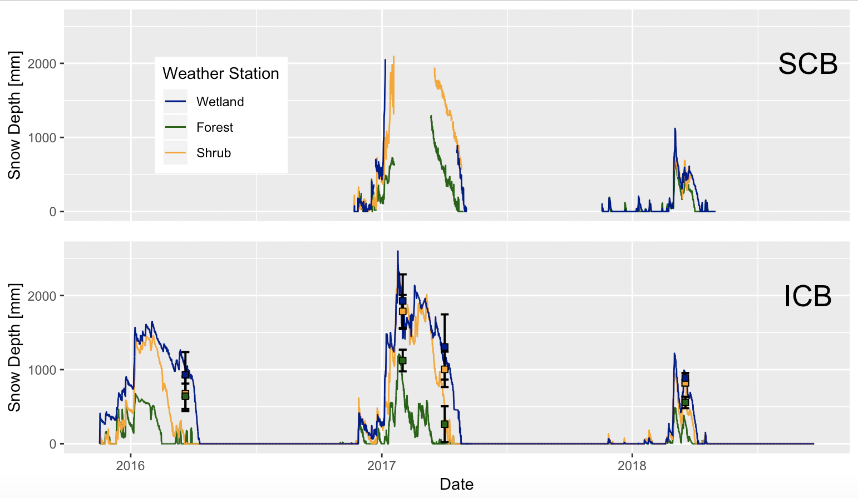

Figure B5: Snow depth (in mm) for Sugarloaf Creek Basin (top) and Illilouette Creek Basin (bottom) as measured from images taken four times each day at wetland, shrub, and forest weather station sites. Additionally, error bars (squares indicating mean, and bars indicating standard deviation) are shown for manually measured snow depths in ICB.

# Appendix C: Precipitation Gap Filling

The first step in obtaining accurate precipitation timeseries was to remove all incorrect precipitation records. This includes times when the rain gauge is upside down or damaged in any other visible way, or when false precipitation measurements are clearly caused by a person or animal moving the gauge (e.g., when maintenance occurred or when time lapse cameras show that an animal disturbed the station). The next step was to set precipitation record as missing for the times when the station recorded zero precipitation, but the surrounding stations have recorded a precipitation event and there was a pulse in shallow soil moisture content. This type of missing data has mostly occurred in the winter months when the tipping bucket was likely to be frozen and/or the rain gauge was covered with snow. After this step, in Sugarloaf Creek Basin, 32% of precipitation at the forest, 25% at the shrub, and 27% at the wetland station was missing. In Illilouette Creek Basin, these percentages were: 24%, 10%, and 19% respectively.

If all three stations were missing precipitation record, then a combination of snow melt amounts and shallow soil water inputs was used to gap-fill the record (Figure C1). Snow melt was measured as a decrease in snow depth. Snow depth was converted to water equivalent using density of 0.4. and then was rounded to the nearest 0.1 inch to match the resolution of the precipitation gauge. Due to the record snowpack in 2017 water year (WY), we were not able to measure snow depths above the height of the camera (~220 cm) in SCB. Shallow soil water inputs were estimated by smoothing 10-min soil moisture content at the depth of 12 cm, and then depth integrating moisture content over the time series. Positive change was counted as water accumulation, and negative change was counted as water loss. While shallow soil water input metric is not a good approximation for the precipitation amount, it is a good metric to detect precipitation and melt events in the absence of rain gauge data.

In the final step, a predictive mean matching (mice.impute.pmm function in R package “MICE”) was used to perform multiple imputations of the missing data when there was record for at least one station. Predictive mean matching (Little 1988) is an advantageous technique for large datasets having non-normal distributions, and discrete values with physical bounds (in our case precipitation cannot be less than zero). Five imputations were performed with a random selection of one observed value from a pool of 5 donors of the closest predicted values. After this step, precipitation record was complete with no missing values. All predictions were rounded to the nearest 0.1 inch (2.54 mm), since that is the smallest measurement detected by the rain gauge.







*Figure C1: Tipping bucket, snow melt, and shallow soil water inputs records for forest (top), shrub (middle), and wetland (bottom) stations in SCB.*

# Appendix D: Detailed soil moisture model results

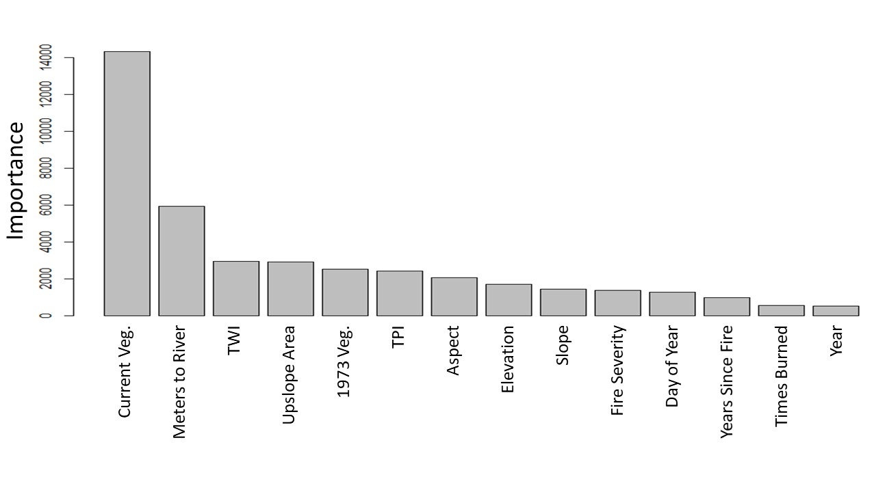

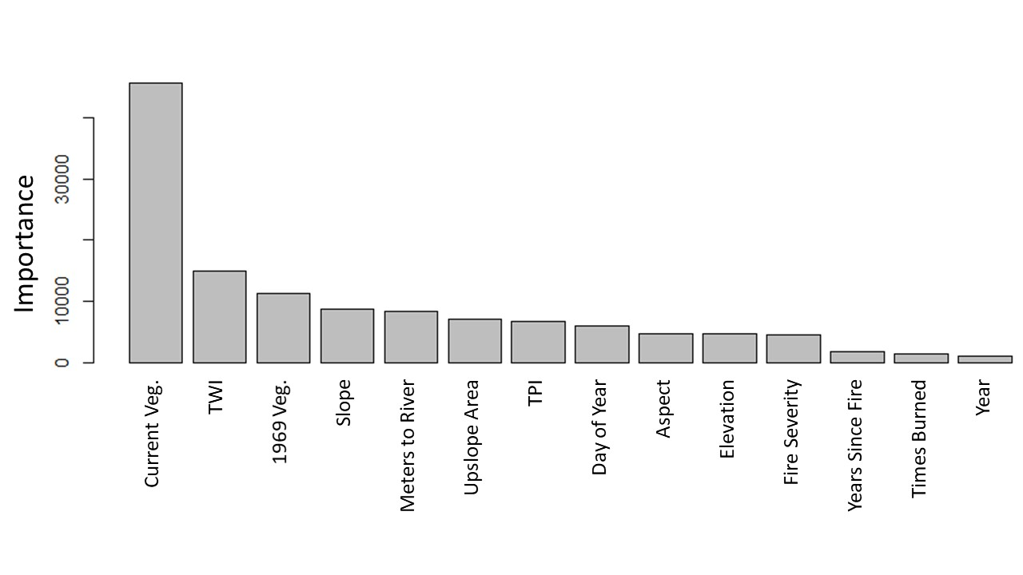

Figure D1: Relative importance of each variable in predicting plot-level soil moisture for Sugarloaf Creek Basin (top) and Illilouette Creek Basin (bottom). Variables include 2014 vegetation (Current Veg), Distance from nearest stream, topographic wetness index at a 10m resolution (TWI), Upslope contributing area, 1973 vegetation, topographic position index calculated at a scale of 300m (TPI), aspect, elevation, slope, maximum fire severity, days since January 1 for the measurement (Day of Year), years since fire, times burned, and year of the measurement.

*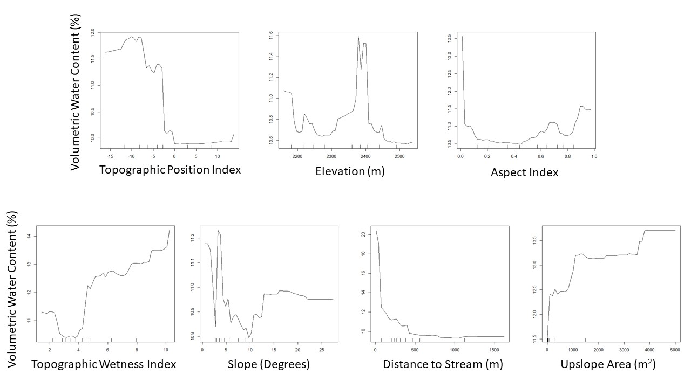Figure D2: Partial plots showing how the mean soil moisture (across all other possible variable values) varies with each topographic variable.*

*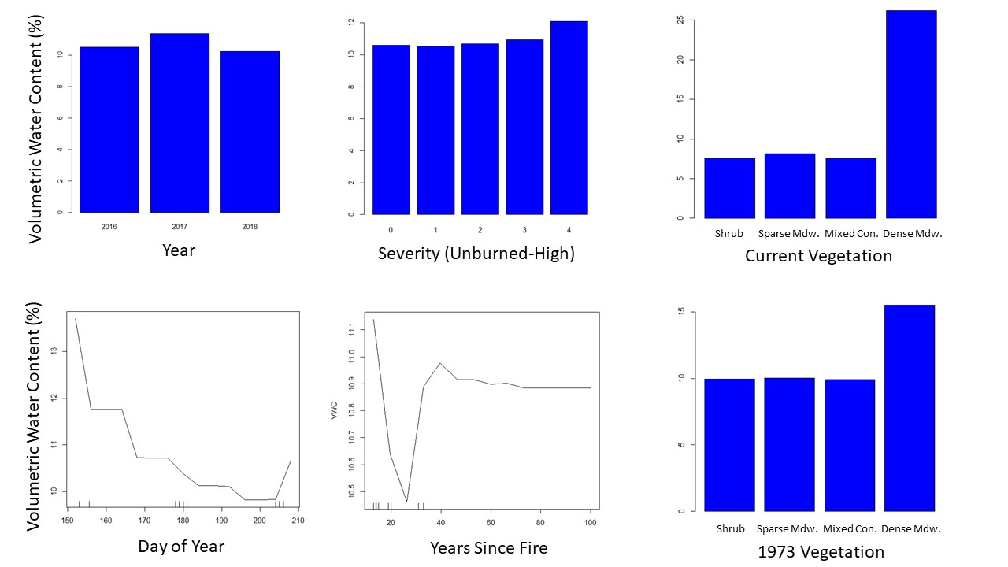Figure D3: Partial plots showing how the mean soil moisture (across all other possible variable values) varies with each variable. Those variables treated as factors rather than numbers in the model are shown as bar plots. Number of fires varied moisture by less than 0.4%, and is not shown.*



Figure D4. Modeled versus measured soil moisture in SCB (site means). Red points are calculated using a model trained on ICB data; black points are from a model trained on SCB data.



Figure D5. Errors in predicting SCB soil moisture using a model trained on SCB data (grey) and on ICB data (red).

Appendix E: Details of landscape changes

**Methods:**

In order to quantify landscape changes in SCB, as well as compare these changes to ICB, we used the FRAGSTATS package to calculate various land cover metrics.

For both ICB and and SCB, the land cover was divided into four broad vegetation classes: forest, shrub, sparse meadow, and dense meadow. Areas south of the southernmost extent of historical fires were removed from the landscape change analysis, since this area consisted mostly of isolated patches of vegetation surrounded by rock and caused misleading values. Isolated pixels surrounded by different vegetation types were removed from the maps before processing by merging them with the surrounding vegetation type; this minimized differences caused by small isolated patches that were likely due to classification error or would be difficult to capture the same way using two sets of imagery.

For SCB, calculations were performed on vegetation maps created from images taken in 1973 and 2014. For ICB, the imagery dates from 1969/70, 1987, 1997, 2005, and 2012. For both watersheds, the first year of imagery (either 1973 or 1969/70) coincides with the end of a long period of fire suppression, prior to the use of managed wildfire.

Landscape Metrics:

Diversity indices have been shown to capture fire-related landscape changes well (Romme, 1982). They describe heterogeneity by measuring how patches of vegetation are distributed spatially across the landscape. We evaluated the following diversity metrics:

Shannon’s Evenness Index (SHEI) is the Shannon’s Diversity Index (calculated using information theory) divided by the maximum diversity given the number of cover types present (McGarigal et al., 2012). An evenness index of 1 would mean that all vegetation types were equally represented in the landscape; higher evenness means more landscape diversity.

Simpson’s Evenness Index (SIEI) is similar, but is calculated using the probability that any two cells selected at random would be different patch types (McGarigal et al., 2012). Again, a value of 1 would mean that all patch types cover an equal area, and a value near 0 would mean that one type dominated nearly all of the landscape. We include both evenness indices in order to verify that the exact method of calculating evenness does not affect our results.

Aggregation Index (AI) is a measure of how much each vegetation type is clumped into a few large groups (high aggregation) or spread into many small groups (low aggregation).

Patch properties within each class:

Patch properties describe local-scale heterogeneity and the size and shape of individual vegetation patches. For this study, we selected metrics which have been shown to be consistent across many different landscapes (Cushman et al., 2008):

Largest patch percent area (LPI) gives the percent of the total vegetated area taken up by the largest contiguous vegetation patch within each vegetation class. This metric gives an idea of the maximum area dominated by a single type of overstory.

Fractal dimension (FRAC) measures how complex and plane-filling the shapes are by using the relationship between the area and perimeter of a patch. As the dimension approaches 2, perimeter is maximized for a given area of coverage, while for simple geometries such as squares or circles the dimension is 1 (McGarigal et al., 2012). For example: a vegetation class with a low fractal dimension whose largest patch covers a large area indicates a spatially homogeneous region. On the other hand, a high fractal dimension suggests an increase in the total length of boundaries between patches of different types, thus increasing local heterogeneity.

In addition to these metrics, we calculated the mean and standard deviation of the areas of all patches within each vegetation class. These measures help capture the changes in the distribution of patch sizes.

All calculations were made on a rasterized vegetation map with a spatial resolution of 5 meters. This spatial resolution was chosen to match with calculations made on ICB vegetation (CITE Boisrame et al. FEM).

**Results and Discussion:**

Sugarloaf Creek Basin (SCB) showed a much smaller degree of landscape change than Illilouette Creek Basin (ICB). Diversity indices increased over time for both watersheds, but the change was negligible for SCB, showing that landscape diversity rose only very slightly in response to fire (Figure E1). The landscape-scale aggregation index increased slightly over time in SCB, in contrast to a decrease in ICB (Figure E2). This could be due to fires creating larger areas of sparse meadow that are more aggregated than pre-burn meadow areas (Figure E3b). The size of the largest vegetation patches did not vary appreciably in SCB between 1973 and 2014, with the exception of sparse meadows (Figure E3). The mean and standard deviation of patch sizes, however, showed similar trends to ICB (Figure E4). Most notably, conifer patches got smaller and less varied in size following 4 decades of fire (Figure E4). While fractal dimension increased for all vegetation types in ICB, it remained flat or decreased slightly in SCB (Figure E5). This may partially be due to fires creating a small number of new fairly homogeneous patches with simple geometries, but the small amount of change demonstrates that patch properties varied very little in response to fire in SCB.

Relative proportions of each vegetation type were similar between the two watersheds (Figure E6; note that these proportions do not account for exposed rock). Both watersheds also had similar Shannon’s Evenness Index values in their pre-fire/post-suppression states (Figure E1). These similarities show that, despite differences discussed in the main text, the large-scale land cover types and distributions are comparable between these watersheds, making them useful to use as two case studies demonstrating how fire affects two similar landscapes in areas with slightly different climatology and geology.

*Figure E1. Shannon’s Evenness Index calculated for both ICB and SCB for each year that we created vegetation maps from aerial imagery.*

*Figure E2. Aggregation Index calculated for both ICB and SCB for each year that we created vegetation maps from aerial imagery.*

a)

b)

*Figure E3. Largest patch index (LPI; the percent of the total area occupied by the largest contiguous patch of vegetation) for each vegetation class for both ICB and SCB. Conifer (a) is shown separately from the other vegetation classes (b) due to large differences in scale.*



(c) (d)

*Figure E4. Mean and standard deviation of patch size for each vegetation class for both ICB (a-b) and SCB (c-d). Conifer is shown separately from the other vegetation classes due to large differences in scale.*

*Figure E5. Mean area-weighted fractal dimension of patches for each vegetation class for both ICB and SCB. 1997 is omitted due to small differences in mapping protocol affecting patch fractal dimension.*

*Figure E6. Percent of the total vegetated area covered by each vegetation class for both ICB and SCB. Conifer is shown separately from the other vegetation classes due to large differences in scale.*

**Literature Cited**

Henn, B., A. J. Newman, B. Livneh, C. Daly, and J. D. Lundquist. 2018. An assessment of differences in gridded precipitation datasets in complex terrain. Journal of Hydrology **556**:1205-1219.

Little, R. J. A. 1988. Missing-data adjustments in large surveys. Journal of Business & Economic Statistics **6**:287-296.